Skill 4
2520030296
Mythri
- Process Synchronization and Child Process Monitoring Using waitpid().

To Retrieve PATH Variable, Parse Search Directories, Locate Executables, Verify Permissions, Handle Missing Commands, Test Command Resolution.

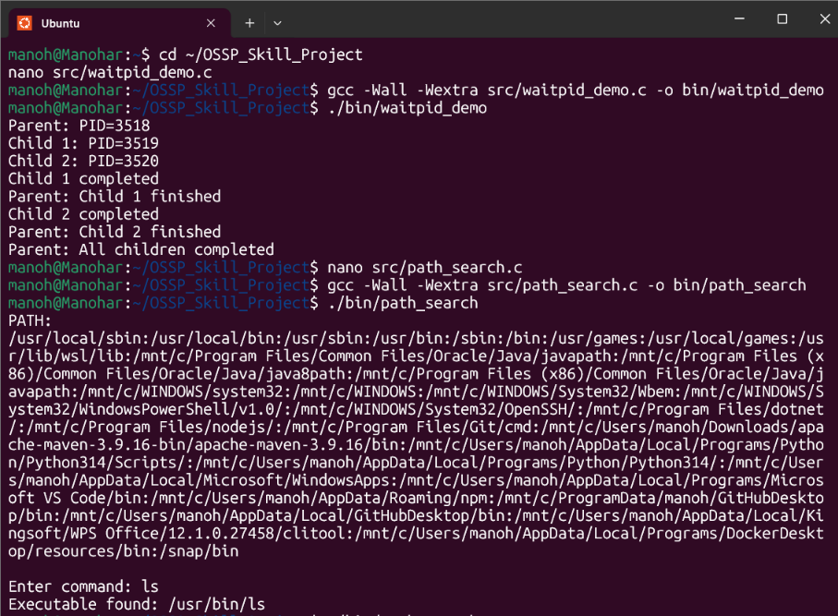

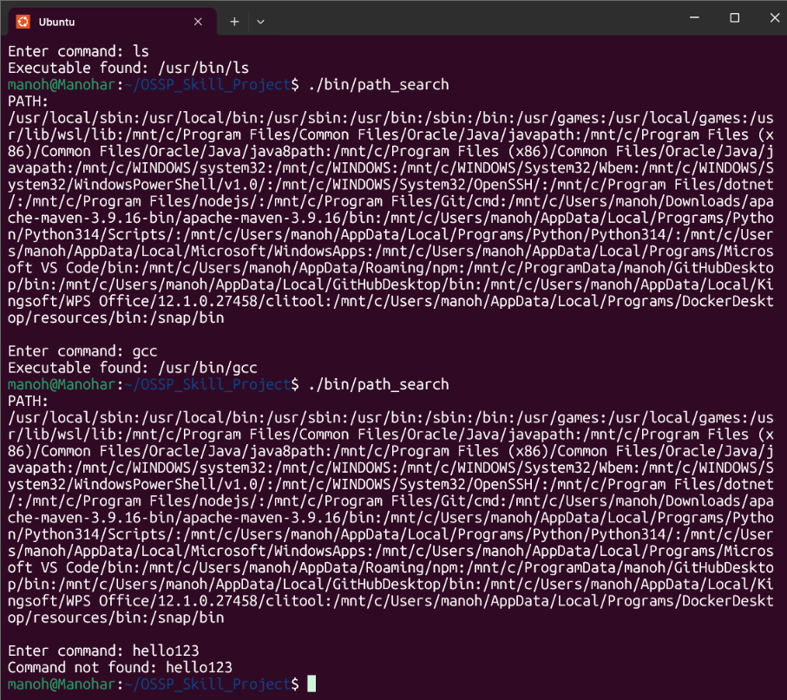

- To Detect Variable References, Expand Values, Handle Undefined Variables, Update Tokens, Support Nested Variables, Test Expansion Logic.

To Identify Built-ins, Create Dispatch Table, Execute In-Process Commands, Handle Invalid Commands, Maintain State, Test Dispatch Logic.
